Coffee Extracts – Green, Instant & Liquid Varieties for Global Export
By The Export Express | Premium Indian Coffee Extract Supplier
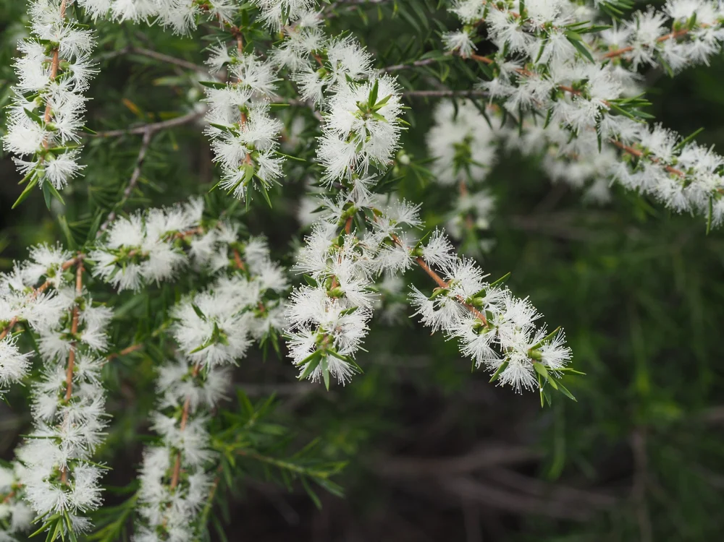

Introduction
Coffee is more than a beverage — it’s an experience of aroma, energy, and wellness. At The Export Express, we bring to the world India’s most refined Coffee Extracts, crafted from carefully selected Arabica and Robusta beans sourced from the coffee-rich regions of Coorg, Chikkamagaluru, and Wayanad.
Our product range includes Green Coffee Extract, Instant (Powdered) Coffee Extract, and Liquid Coffee Extracts, each formulated to meet the diverse needs of global beverage, nutraceutical, cosmetic, and functional food industries. With high purity standards, controlled caffeine content, and certified quality, we deliver bulk and private-label coffee extracts ready for international markets.

🌱 What Are Coffee Extracts?
Coffee extracts are concentrated derivatives of roasted or unroasted coffee beans. Through water or alcohol extraction, key compounds such as chlorogenic acids, caffeine, and antioxidants are retained and standardized for consistent potency.
Each extract form — powder or liquid — serves distinct purposes:
- Green Coffee Extract: Rich in chlorogenic acid, ideal for wellness and weight management formulations.
- Instant Coffee Extract: Fully soluble powdered form, perfect for beverages and flavoring.
- Liquid Coffee Extract: Concentrated essence for cosmetics, aromatherapy, and liquid formulations.

🟢 Green Coffee Extract – Natural Antioxidant Power
Form: Solid Powder Packaging: HDPE Plastic Drum / Packet Shelf Life: 24–36 Months
Available Grades: 45% and 60% Chlorogenic Acid (HPLC Standardized) Origin: India
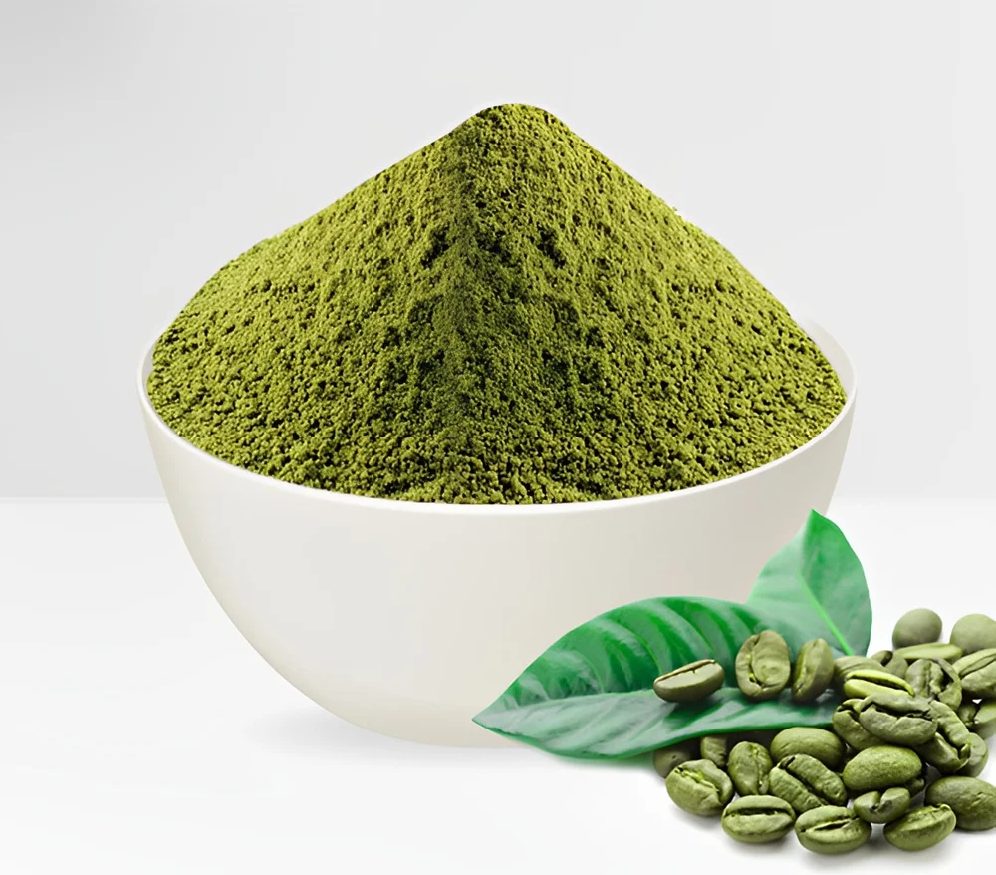
Caption: “Green Coffee Extract Powder – High Chlorogenic Acid for Wellness Applications”

Product Overview
Our Green Coffee Extract is derived from unroasted Coffea robusta and Coffea arabica beans. It retains its natural light cream-to-yellow color and is standardized for chlorogenic acid, a powerful antioxidant linked with metabolism, heart health, and liver protection.

Key Specifications
Parameter | Specification
Botanical Name | Coffea robusta / Coffea arabica
Active Ingredient | Chlorogenic Acid 45%–60%
Color | Light Cream to Yellow
Plant Part Used | Seeds
Solubility | Water Soluble
Purity | 99.99%
Grade | Food Grade
Shelf Life | 2 Years
Packaging Size | 25 kg Drum / 1 kg Packet
Country of Origin | India

Health Benefits
- Supports Weight Management: Promotes fat metabolism and glucose balance.
- Powerful Antioxidant: Neutralizes free radicals and supports skin and cellular health.
- Boosts Energy Naturally: Provides gentle caffeine stimulation without jitters.
- Liver & Heart Protection: Aids detoxification and maintains cholesterol balance.

Applications
- Nutraceutical formulations (capsules, tablets, detox drinks)
- Functional beverages and weight management blends
- Skin and cosmetic products for antioxidant enhancement

☕ Instant Coffee Extract (Powder Form)
Form: Powder Packaging Size: 25 kg Packaging Type: HDPE Drum / Plastic Container
Shelf Life: 36 Months Availability: In Stock
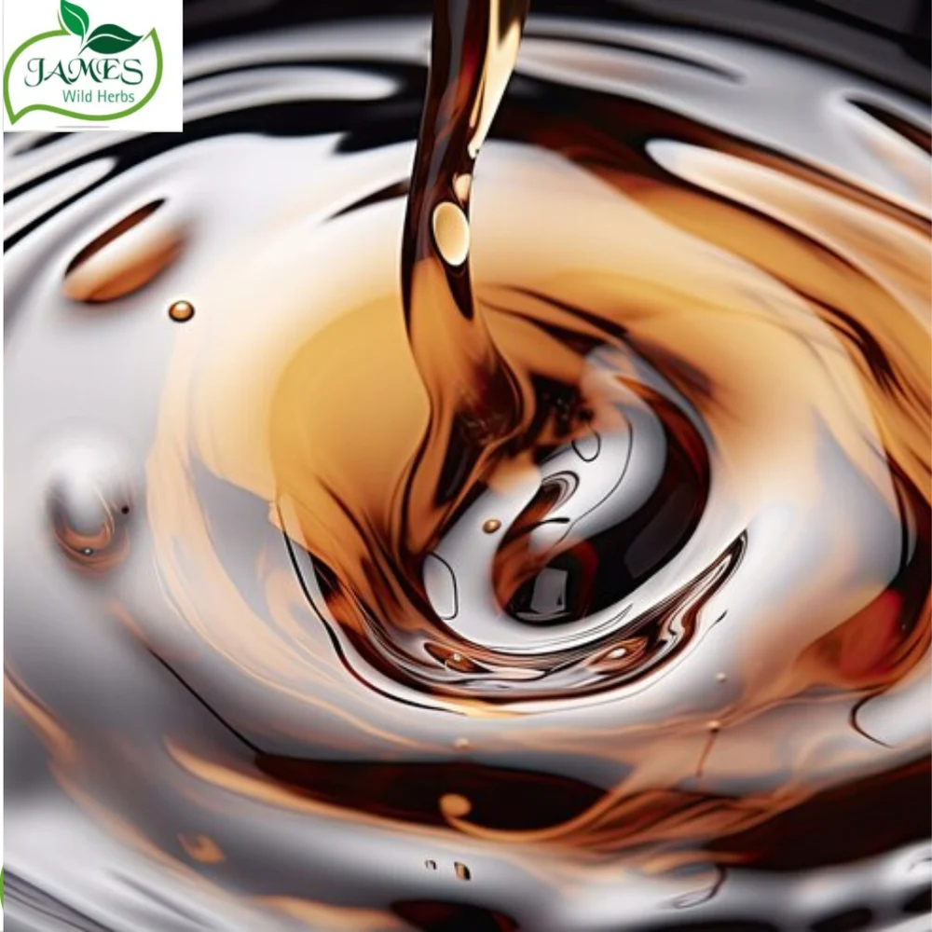
Caption: “Instant Coffee Extract – Water Soluble Powder for Beverage Blends

Product Overview
Instant Coffee Extract Powder delivers pure, soluble coffee flavor and aroma suitable for beverage and food manufacturers. Our process ensures full retention of volatile oils and caffeine content for authentic flavor.

Key Features
- Fully Water Soluble: Instant dispersion in hot or cold liquids.
- Aromatic & Flavorful: Retains natural coffee oils and richness.
- High Caffeine Content: Ideal for energy beverages and strong coffee blends.
- Long Shelf Life: Spray-dried for maximum stability and aroma preservation.

Applications
Industry | Use Case
Beverage Industry | RTD coffee, instant coffee mixes, energy drinks
Bakery & Desserts | Coffee flavoring in chocolates, ice creams, and pastries
Nutraceuticals | Functional drink powders and meal replacements
Perfumery & Fragrance | Natural coffee essence base for aromatic blends

Technical Profile
Parameter | Specification
Color | Dark Brown
Aroma | Rich, Roasted Coffee
Caffeine | 2.0–3.5%
Moisture Content | ≤ 5%
Solubility | 100% in Water
Storage | Cool, Dry, Airtight Container
Shelf Life | 3 Years

☕ Coffee Liquid Extract – Concentrated Natural Essence
Form: Liquid Packaging: 1 kg – 180 kg Bottles & Drums Shelf Life: 24 Months
Origin: India Purity: 100% Natural Grade: Food / Cosmetic
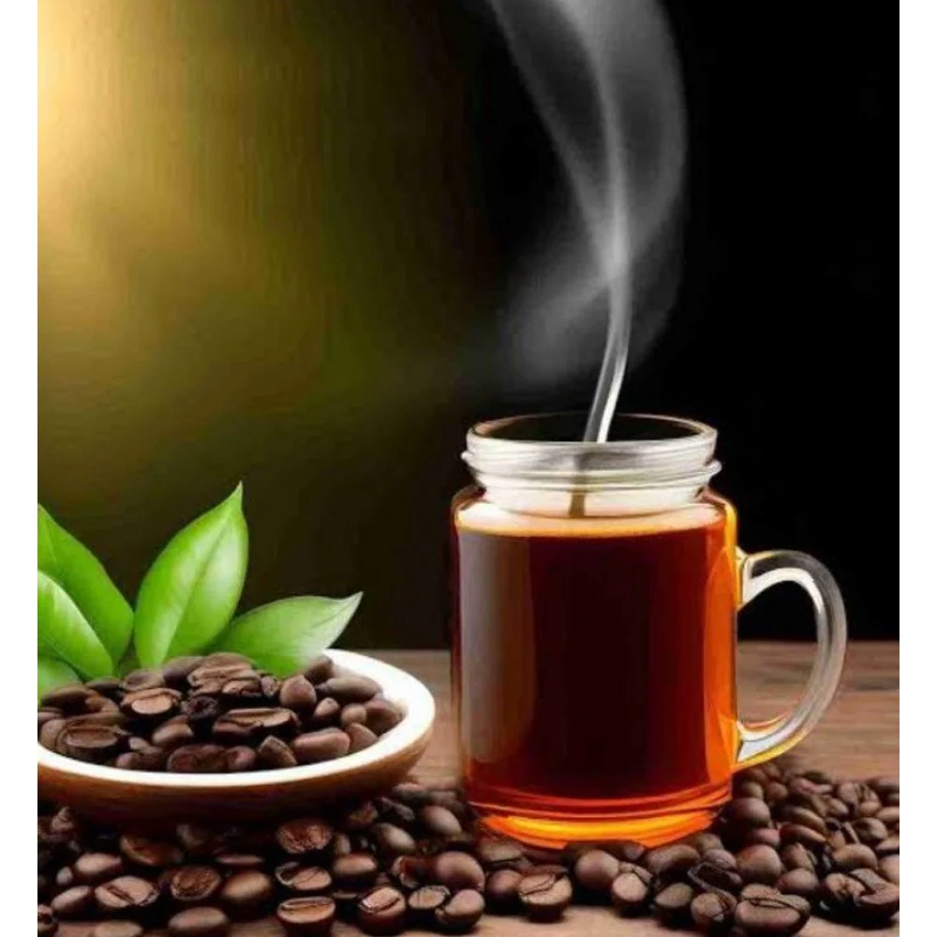
Caption: Liquid Coffee Extract – 100% Natural Aroma for Cosmetics and Flavoring

Overview
Coffee Liquid Extract captures the purest form of coffee’s aroma and bioactives in a ready-to-use, water or oil-soluble format. Sourced from premium Arabica and Robusta beans, it is suitable for beverages, cosmetics, and therapeutic formulations.

Types Available
- Water-Soluble Coffee Extract: For beverages and food formulations
- Oil-Soluble Coffee Extract: For cosmetic creams and perfumery applications

Key Benefits
- Rich Aroma & Flavor: Retains volatile compounds from freshly brewed coffee
- Antioxidant Protection: Fights oxidative stress and skin damage
- Anti-Inflammatory: Soothes skin and reduces puffiness or redness
- Improves Circulation: Enhances skin vitality and reduces under-eye darkness
- Versatile Use: Ideal for cosmetics, aromatherapy, and gourmet flavoring

Cosmetic Applications
- Anti-aging creams and serums
- Under-eye gels and face masks
- Hair growth formulations and shampoos
- Exfoliating scrubs and lotions

Food & Beverage Applications
- Ready-to-drink coffees and syrups
- Bakery fillings and flavor bases
- Ice creams and confectioneries

🧪 Coffee Extract – Technical Summary
Property | Specification
Form | Powder / Liquid
Active Compounds | Caffeine, Chlorogenic Acid, Polyphenols
Grades Available | AAA, AA (Arabica / Robusta)
pH Value | 4.5 – 6.5
Solubility | Water and Oil Soluble
Purity | 99.9% Natural
Packaging Options | Bottle / Drum / Custom Pack
Shelf Life | 2–3 Years
Certifications | ISO, GMP, FSSAI Certified
Country of Origin | India

🌍 Export Applications & Global Demand
With the rising trend toward functional beverages, cosmetic infusions, and clean-label nutraceuticals, Indian coffee extracts are rapidly gaining popularity worldwide.
Top Importing Regions:
- North America – For dietary supplements & beverages
- Europe – For gourmet flavoring and skincare
- Middle East & Asia-Pacific – For instant coffee mixes and cosmetics
Export Strengths of The Export Express:
- Standardized chlorogenic acid and caffeine content
- Reliable bulk supply and OEM packaging
- Global logistics with documentation and COA support

🧭 Why Choose The Export Express for Coffee Extracts
- Diverse Range: Green, Instant, and Liquid extracts for multiple applications
- Certified Quality: ISO, GMP, FSSAI-approved manufacturing processes
- Sustainably Sourced: Coffee beans grown in pesticide-free plantations
- Custom Packaging: From 1 kg trial packs to 25–180 kg export drums
- Private Label Manufacturing: Tailored for global wellness and F&B brands

📦 Packaging & Storage
- Standard Sizes: 1 kg, 5 kg, 25 kg, 50 kg, and 180 kg drums
- Material: HDPE, PET, or glass containers with double-sealed lining
- Storage Instructions: Keep in cool, dry, and airtight containers away from light
- Shelf Life: 24–36 months (depending on form and grade)

🏁 Conclusion
At The Export Express, we bring the heritage of Indian coffee to the global stage through our premium coffee extracts. Whether you need green coffee extract for health supplements, instant coffee powder for beverages, or liquid extract for perfumery and cosmetics — our products deliver purity, consistency, and international export quality.
With modern processing, certified quality assurance, and sustainable sourcing, we ensure every drop and granule embodies the rich legacy of Indian coffee cultivation.
Partner with The Export Express — your trusted supplier for bulk and private-label Coffee Extracts worldwide.

Keywords:
Coffee Extract Export India | Green Coffee Extract Supplier | Instant Coffee Extract | Liquid Coffee Extract Exporter | Coffee Extract Powder | Arabica Robusta Coffee Extract | Herbal Extract Export India | The Export Express

